

Overview:
SEWP is a United States governmentwide acquisition contract (GWAC) authorized by the U.S. Office of Management and Budget (OMB) and managed by the National Aeronautics and Space Administration (NASA). All Federal agencies, including the Department of Defense (DOD), and government contractors are able to purchase IT equipment and services from SEWP-authorized resellers (known as "Contract Holders"). In Fiscal Year 2009, more than 70 federal agencies purchased IT solutions through the contract vehicle. As of 2018, 87 cabinet-level agencies and commissions have used SEWP. SEWP covers a vast range of IT solutions such as such as laptops, servers, tablets, peripherals, network equipment, storage systems, software products, cloud based services, telecommunications, security tools, as well as product-centric services such as installation, training, engineering, and maintenance services. As of October 1,2020, the SEWP surcharge for all orders is a 0.34%. The fee is included in the price of all products and is not separately listed on quotes. It is the Contract Holder’s responsibility to pay the fee from their quoted product prices.

Better Direct, LLC
Period of Performance: 05/01/2020 – 04/30/2025
Group A: NNG15SD45B - Full & Open
Group B: NNG15SD10B - HubZone & SDVOSB Group C: NNG15SD65B - Small Business Contract Surcharge fee: 0.34%
Credit Card Accepted: Yes (VISA/MasterCard/AMEX)

Program Manager POC: Matthew Walz
Email: matthew.walz@betterdirect.com
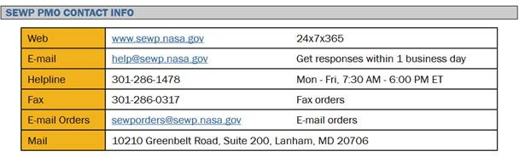
Phone: 480-921-3858x680

Deputy Program Manager
POC: Kim Lambert
Email: kim@betterdirect.com Phone: 480-921-3858x133

POP: April 30, 2015- April 29, 2025
(5-Year Base w/a 5-Year Option Period)

https://betterdirect.com/federal-contracts/

Ordering process:
Click here for the SEWP ordering Information

Requesting quote process:
There are 3 methods available to obtain quotes for products and services which are listed in order of preference below.
- Utilize the NASA SEWP QRT at the following URL: https://sewp.nasa.gov/sewp5public/security/login.sa
- Contact a Better Direct Representative directly sales representative via phone by dialing (800)-921-3858 Option 0
- Contact us via email at mitchel@betterdirect.com

Fair Opportunity:
FAR 16.505(b) (1) provides that each contractor shall be given fair opportunity to be considered for each order under the micro- purchase threshold, typically $10,000, and issued under multiple award contracts.
Please click here for FAR 16.505(b) fair opportunity information

Questions on orders:
For any questions about orders placed against the SEWP contract, Customer Service can be contacted by calling 866-921-3858 or emailing mitchel@betterdirect.com
When contacting Better Direct, please have your Better Direct order number or purchase order number so we can assist you quickly.

CAGE: 4JN18 UEI: J6EEK881G8H7 Business Size: HUBZone, VOSB, SDVOSB, SB150

